
Loo Roll Challenge
Start in standing with a loo roll
balanced on your forehead.


Almost there…

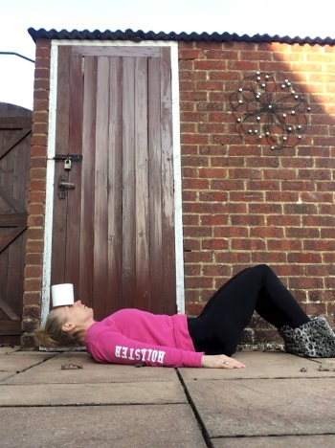

Finish laying on your back with
the loo roll still on your forehead.

Now can you stand back up? How many times can you stand up and get down in 2 minutes without the loo roll falling?

