Animal workout
Set a timer and complete each animal movement for 45 seconds, with 15 seconds rest in between. Do as many as you can in the 45 seconds!
Can you complete this 4 times this week?
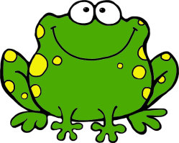 | FROG JUMPS  Hop forwards and backwards like a frog.
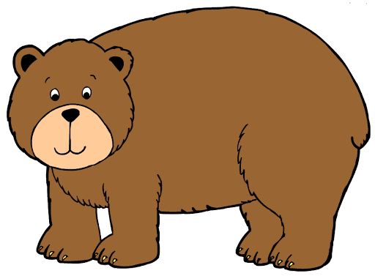 | BEAR CRAWLS  Hands and feet on the floor, hips high – crawl 4 paces forward and 4 paces back.
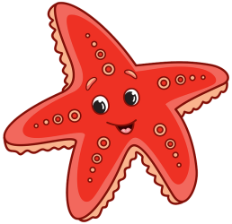 | STARFISH JUMPS  Jumping jacks as fast as you can with arms and legs spread wide.
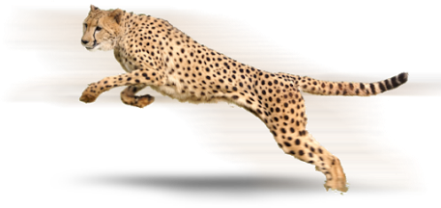 | CHEETAH RUN  Run on the spot as FAST as you can!
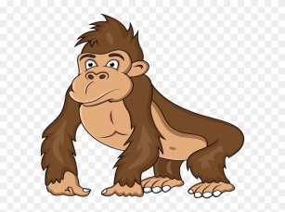 | GORILLA SHUFFLE  Sink into a low squat with knuckles on the floor, take 4 steps forward and 4 steps back.
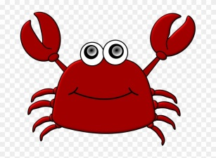 | CRAB CRAWL  Sit and place your palms flat on the floor behind you near your hips. Lift up of the ground and move sideways for 4 steps then move back.
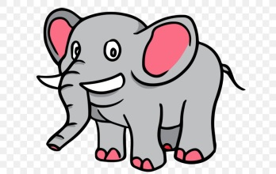 | ELEPHANT STOMPS  March in place lifting your knees as high as you can!

